IT2654 Systems Administration & Security

Tutorial 6

Discuss within your groups and prepare the answers to be presented in class.

- How does security template improves Windows Server security? What additional benefits does it have in a multiple servers environment?
Security templates are a collection of pre-defined configurations on the server (eg: Password configuration like minimum length, lockdown period)

Tool is the security configuration and analysis tool. It will help you config the server such that server will take on template value and not server value.

Can apply 1 template to other servers thus it is easier to maintain and there will be consistency across servers, all servers will have the standard configuration
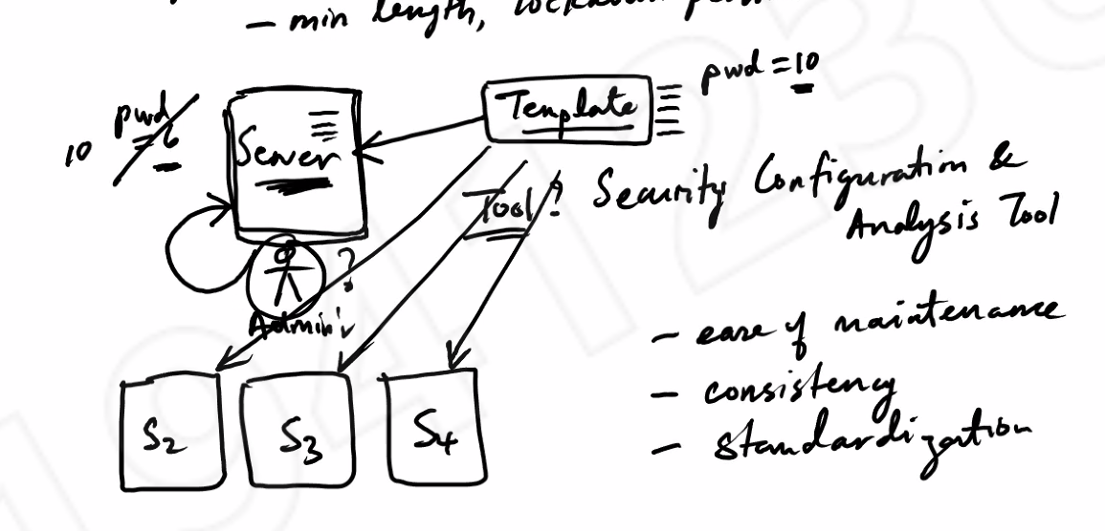

- What is auditing in a Windows Server? Why is it not advisable to audit everything that happens on the server? How does one view the audit records in a Windows Server?
Auditing: tracks the events in the server eg.: log in (success/failure); open a file (success/failure) These can be stored into a log file.

It takes up system resources (like CPU). You need to be selective in what you want to log.

You can view the files in Event Viewer. It has a lot of tools like filtering.
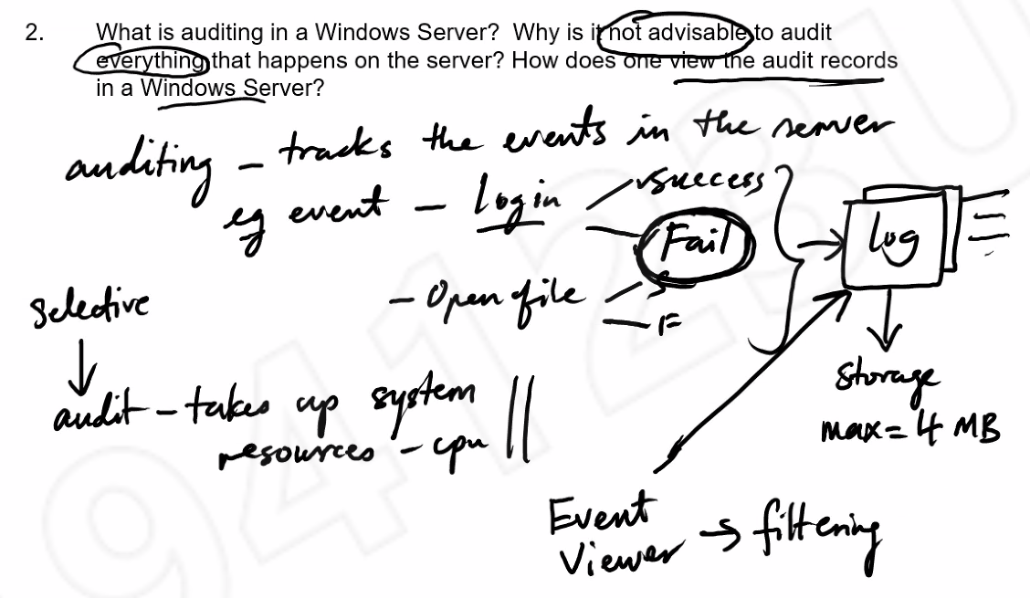

- What are the differences between EFS and Bitlocker?
EFS: Encrypting File System

EFS: Encrypt files or folder, software based, anyone can use, uses user password to encrypt
Bitlocker: Encrypt entire drive or volume, uses TPM (hardware based), only Administrator can turn on/off, uses AES key to encrypt

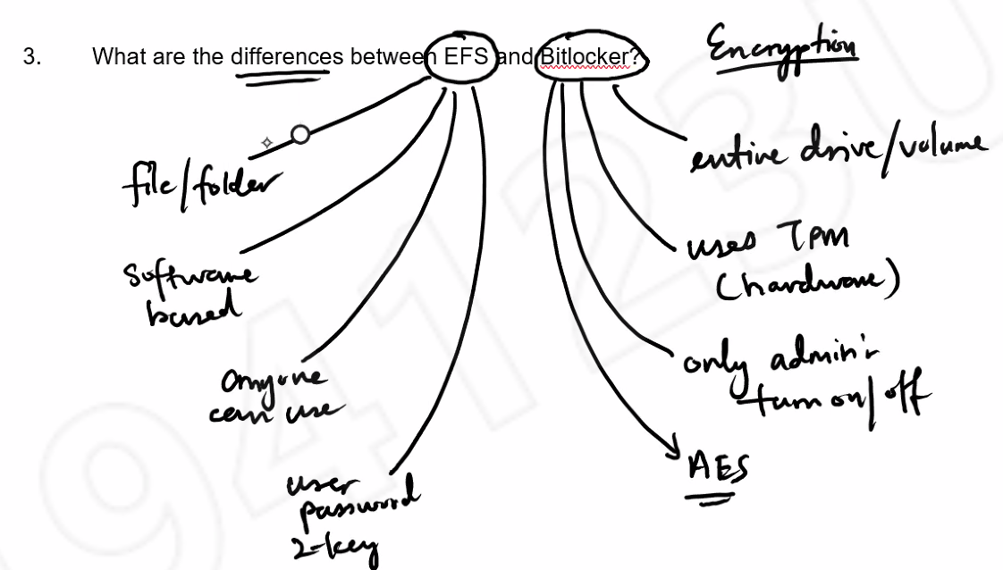

- Compare the 2 diagrams below.

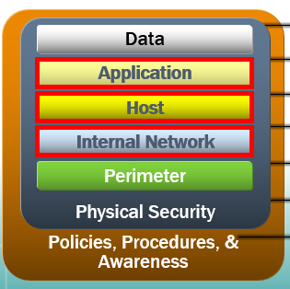  Fig A | 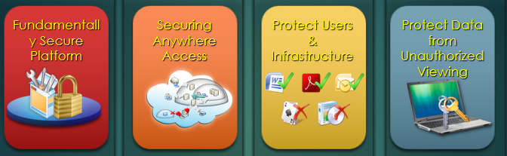  Fig B
Fig B was covered in the lecture. Summarized all the security features covered from week 1 to week 6 by relating them to Fig A.
Data: EFS, BitLocker, ACL (Permission)
Application: Antivirus, AppLocker
Host: Security Template, Authentication, Patch management
Internal Network: IPsec (will encrypt data sent over a network)
Perimeter: Firewall, IDS (Intrusion detection system)
Physical Security: Guards, locks, camera etc
